# MERN Troubleshooting

* [MERN Cheatsheet](https://docs.google.com/document/d/1cYuL3TRUZLErwkA3bBhvIRTrSdMlYzufkMx5dMtCg0k/edit)

## Webpack

### Installed globally

Delete the webpack folders inside of **C:\users\username\node_modules**

## Windows

### Space in user name

configure **npm** to use Windows Short Names

alternatively rename their username

## Frontend

#### create-react-app

##### Incorrect jest version

* Create a file named **.env** file and add **SKIP_PREFLIGHT_CHECK=true** in the file

### Extra Renders

* <React.StrictMode> in **index.js**
  + causes extra renders only in development when using hooks
  + intentional behavior to help catch unintended side effects, can be removed to avoid extra re-renders but it is there to help catch difficult to find bugs.

### Can’t perform a React state update on an unmounted component

* the component being updated is no longer "mounted", no longer displayed
* usually happens if you go to a different page while an HTTP request (like an API request) was still pending for the previous page and then it finishes but that page is no longer active so the component cannot be updated

### A component is changing an uncontrolled input

* Make sure the **<input>** has an onChange and the **<input>** has a **value={yourStateVar}**

### Error: No valid exports main found for '\node_modules\colorette'

* Full error: create-react-app starting error - Error: No valid exports main found for '\node_modules\colorette'
* Uninstall node and then [install](https://nodejs.org/en/download/current/) version 14.5+
* If you are having problems uninstalling or switching node versions on MAC, you can download nvm. [How to switch node versions with NVM.](https://reactgo.com/nvm-uninstall-active-node-version/)

### API Calls

* [Access-Control-Allow-Origin](https://create-react-app.dev/docs/proxying-api-requests-in-development/) issues.

## Backend

### Installing MongoDB

#### Mac

##### [Install on M1](https://www.youtube.com/watch?v=f3iFaiBGVYw)

##### Permission Errors

* [Download](https://www.mongodb.com/try/download/community) the installer from the right side of the page and then use the downloaded file to install

### Deployment

* **mv: cannot stat 'build': No such file or directory**
  + you forgot the deployment step that has you delete the **.gitignore** in the **client** folder, search **gitignore** on the deployment steps page

## npm

### **npx create-react-app** not working

* Before you re-test anything, re-open your terminal
* Make sure you have it installed globally **npm i -g create-react-app** then try **npx create-react-app app-name** again

#### Space in Windows username operation not permitted, mkdir

* If you have a space in your windows username, this could be causing the problem

1. Get your current path: **npm config get prefix**
2. Set the npm config with **your path from step 1** but replace spaces with **~1** as seen in this example: npm config set cache "C:\Users\Firstname~1\AppData\Roaming\npm-cache" --global
   * This is an example where Firstname is a first name and the ~1 replaces where the space and lastname would be, you need to use your own path
3. 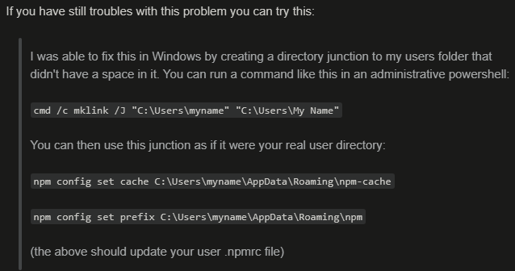

### ERESOLVE

* Unable to resolve dependency tree
  + npm install PACKAGE-NAME --save --legacy-peer-deps

## Nodemon

### MODULE_NOT_FOUND

* Error: Cannot find module **‘packageName’**
  + You probably forgot to install the package or misspelled it.
* **some\path\index.js'** 
  + **nodemon server.js** this probably means you have your terminal open to a folder that your **server.js** is not in. Make sure to cd to the folder that has your **server.js** then try again.

### EADDRINUSE: address already in use

* You have another terminal already running this same port, stop the other terminal.

### Windows

#### Running scripts is disabled



* Don’t use powershell, change Vscode to use cmd
  + Ctrl + shift + p then type: shell
    - Select cmd
    - If cmd is not available
    - Ctrl + shift + p then type open settings (JSON)
    - "Terminal.integrated.shell.windows": "C:\\Windows\\System32\\cmd.exe"
* To keep using powershell, run this command in powershell: Set-ExecutionPolicy unrestricted

## Delete all **node_models** folders from terminal

* **find . -name 'node_modules' -type d -prune -exec rm -rf '{}' +**